**SALES INSIGHTS**

**A PROJECT REPORT**

***Submitted by***

**HARSHIL JAYANTBHARTHI GOSAI**

**180410107031**

***In fulfillment for the award of the degree of***

**BACHELOR OF ENGINEERING**

**in**

**Computer Engineering**

**Sardar Vallabhbhai Patel Institute of Technology, Vasad**

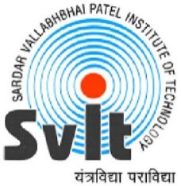 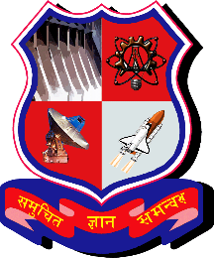

**Gujarat Technological University, Ahmedabad**

**April, 2022**